**Excel Assignment – 6**

Que.1) What are the various elements of the Excel interface? Describe how they're used.

Ans - The following are the basic components of the Microsoft Excel Interface:

* 1. Quick Access Toolbar
  2. File Tab
  3. Title Bar

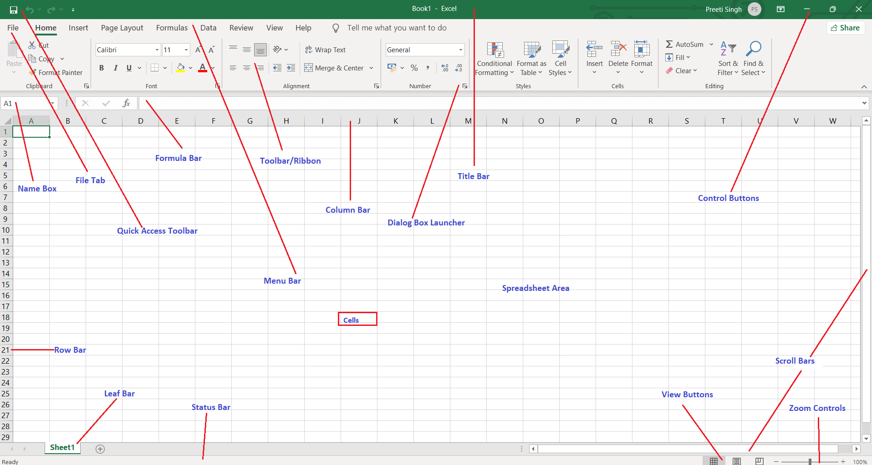

* 1. Control Buttons
  2. Menu Bar
  3. Ribbon/Toolbar
  4. Dialog Box Launcher
  5. Name Box
  6. Formula Bar
  7. Scroll Bars
  8. Spreadsheet Area
  9. Leaf Bar
  10. Column Bar
  11. Row Bar Cells
  12. Cells
  13. Status Bar
  14. View Buttons
  15. Zoom control

Que.2) Write down the various applications of Excel in the industry.

Ans. - Excel is used across industry for following purposes:

1. Business Analysis
2. People Management
3. Managing Operations
4. Performance Reporting
5. Office Administration
6. Strategic Analysis
7. Project Management
8. Managing Programs
9. Contract Administration
10. Account Management

Que.3) On the ribbon, make a new tab. Add some different groups, insert commands in the groups and name them according to their commands added. Copy and paste the screenshot of the steps you followed.

Ans. - Following Steps were followed to create custom ribbon:

i). Right-click on the ribbon and select Customize the Ribbon.

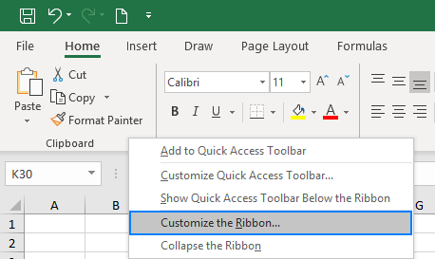

ii) In the Customize the Ribbon window, under the list of tabs, click the New Tab button.

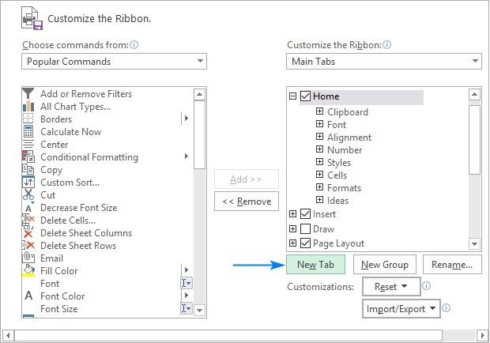

This adds a custom tab with a custom group because commands can only be added to custom groups.

iii) Select the newly created tab, named New Tab (Custom), and click the Rename button to give your tab an appropriate name. In the same manner, change the default name given by Excel to a custom group.

iv) When done, click OK to save the changes.Save the custom ribbon tab.

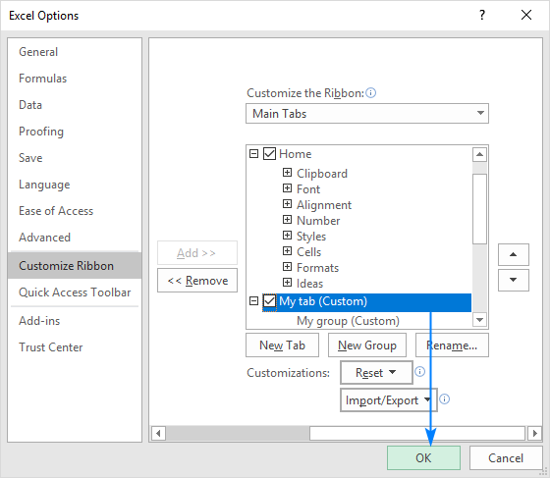

v) As shown in the screenshot below, our custom tab is added to the Excel ribbon immediately, though the custom group is not displayed because it is empty. For the group to show up, it must contain at least one command. We will add commands to our custom tab in a moment but, to be consistent, we will first look at how to create a custom group.Custom ribbon tab in Excel

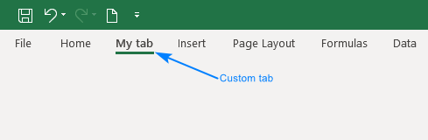

vi) In the right part of the Customize the Ribbon window, select the tab to which you'd like to add a new group.

vii) Click the New Group button. This adds a custom group, named New Group (Custom), at the bottom of the list of groups, meaning the group displays on the far-right end of the tab. To create a new group in a specific location, select the group after which the new group is to appear.

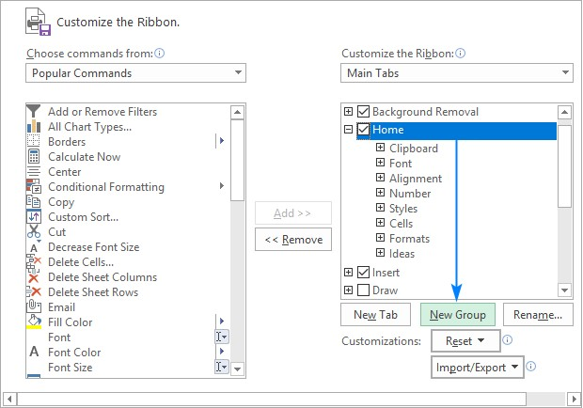

viii) To rename your custom group, select it, click the Rename button, type the desired name, and click OK.

ix) In the Choose commands from drop-down list on the left, select the list from which you want to add commands, for example, Popular Commands or Commands Not in the Ribbon.

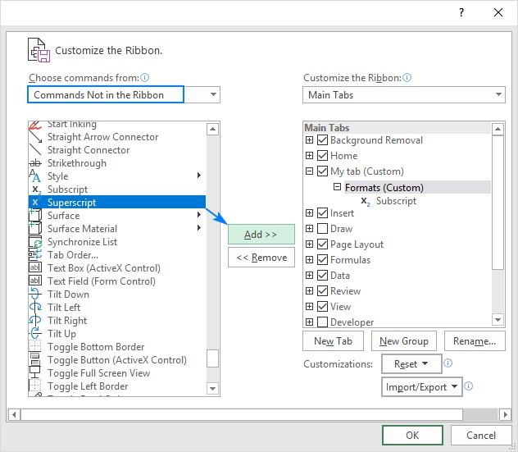

x) In the list of commands on the left, click the command you want to add.

xi) Click the Add button.

xii) Click OK to save the changes.

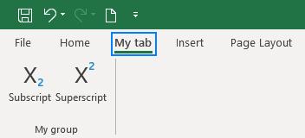

Que. 4) Make a list of different shortcut keys that are only connected to formatting with their functions.

Ans. - Following are the various formatting functions with their shortcuts in excel:

|  |  |
| --- | --- |
| **To do this** | **Press** |
| Open the **Format Cells** dialog box. | Ctrl+1 |
| Format fonts in the **Format Cells** dialog box. | Ctrl+Shift+F or Ctrl+Shift+P |
| Edit the active cell and put the insertion point at the end of its contents. Or, if editing is turned off for the cell, move the insertion point into the formula bar. If editing a formula, toggle Point mode off or on so you can use the arrow keys to create a reference. | F2 |
| Insert a note.  Open and edit a cell note. | Shift+F2  Shift+F2 |
| Insert a threaded comment.  Open and reply to a threaded comment. | Ctrl+Shift+F2  Ctrl+Shift+F2 |
| Open the **Insert** dialog box to insert blank cells. | Ctrl+Shift+Plus sign (+) |
| Open the **Delete** dialog box to delete selected cells. | Ctrl+Minus sign (-) |
| Enter the current time. | Ctrl+Shift+Colon (:) |
| Enter the current date. | Ctrl+Semicolon (;) |
| Switch between displaying cell values or formulas in the worksheet. | Ctrl+Grave accent (`) |
| Copy a formula from the cell above the active cell into the cell or the formula bar. | Ctrl+Apostrophe (') |
| Move the selected cells. | Ctrl+X |
| Copy the selected cells. | Ctrl+C |
| Paste content at the insertion point, replacing any selection. | Ctrl+V |
| Open the **Paste Special** dialog box. | Ctrl+Alt+V |
| Italicize text or remove italic formatting. | Ctrl+I or Ctrl+3 |
| Bold text or remove bold formatting. | Ctrl+B or Ctrl+2 |

|  |  |
| --- | --- |
| **To do this** | **Press** |
| Underline text or remove underline. | Ctrl+U or Ctrl+4 |
| Apply or remove strikethrough formatting. | Ctrl+5 |
| Switch between hiding objects, displaying objects, and displaying placeholders for objects. | Ctrl+6 |
| Apply an outline border to the selected cells. | Ctrl+Shift+Ampers and sign (&) |
| Remove the outline border from the selected cells. | Ctrl+Shift+Unders core (_) |
| Display or hide the outline symbols. | Ctrl+8 |
| Use the **Fill Down** command to copy the contents and format of the topmost cell of a selected range into the cells below. | Ctrl+D |
| Apply the **General** number format. | Ctrl+Shift+Tilde sign (~) |
| Apply the **Currency** format with two decimal places (negative numbers in parentheses). | Ctrl+Shift+Dollar sign ($) |
| Apply the **Percentage** format with no decimal places. | Ctrl+Shift+Percent sign (%) |
| Apply the **Scientific** number format with two decimal places. | Ctrl+Shift+Caret sign (^) |
| Apply the **Date** format with the day, month, and year. | Ctrl+Shift+Number sign (#) |
| Apply the **Time** format with the hour and minute, and AM or PM. | Ctrl+Shift+At sign (@) |
| Apply the **Number** format with two decimal places, thousands separator, and minus sign (-) for negative values. | Ctrl+Shift+Exclam ation point (!) |
| Open the **Insert hyperlink** dialog box. | Ctrl+K |
| Check spelling in the active worksheet or selected range. | F7 |
| Display the **Quick Analysis** options for selected cells that contain data. | Ctrl+Q |
| Display the **Create Table** dialog box. | Ctrl+L or Ctrl+T |
| Open the **Workbook Statistics** dialog box. | Ctrl+Shift+G |

Que.5) What distinguishes Excel from other analytical tools?

Ans. - The worst thing about other expensive applications is they do not deliver results at times. Startups or a small business owners might find it difficult to manage this software. In case they are stuck, clear instructions are mentioned on the tab. Hence, even if we are not well versed in the technology, we can still use this application.

Que.6) Create a table and add a custom header and footer to your table.

Ans. – To create a table:

* 1. Select a cell within your data.
  2. Select Home > Format as Table.
  3. Choose a style for your table.
  4. In the Format as Table dialog box, set your cell range.
  5. Mark if your table has headers.
  6. Select OK.

To add custom header & footers in excel:

1. Click the worksheet where you want to add or change headers or footers.
2. On the Insert tab, in the Text group, click Header & Footer.

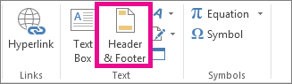

1. Excel displays the worksheet in Page Layout view.
2. To add or edit a header or footer, click the left, center, or right header or footer text box at the top or the bottom of the worksheet page (under Header, or above Footer).
3. Type the new header or footer text.